Container Monitoring API Documentation

1. Endpoints & Headers
URL | https://cms.customs.gov.ph
Load Endpoint | POST /api/load.php
Discharge Endpoint | POST /api/discharge.php
Receive Endpoint | POST /api/receive.php
Release Endpoint | POST /api/release.php
Headers | Content-Type: application/json
Authorization | Bearer YOUR_API_TOKEN
Security Requirement | IP must be whitelisted to access API

2. Field Information

Load Fields
Field Name | Data Type | Example
port | string | Port of Manila
shipping_line | string | Maersk
vessel_name | string | Evergreen
container_no | string | ABC12345678
container_size | int | 40
container_load | string | FULL
registry_no | string | REG0001-26
loading_date | date | 2026-04-20
loading_time | time | 07:30:00
exporter | string | Company A
description | string | Electronics

Release Fields
Field Name | Data Type | Example
port | string | Port of Manila
shipping_line | string | Maersk
vessel_name | string | Evergreen
container_no | string | REL0001
container_size | int | 40
container_load | string | FULL
registry_no | string | REG001
bl_no | string | BL001
master_bl | string | MBL001
discharge_date | date | 2026-04-21
consignee | string | John Doe
notify_party | string | Company XYZ
description | string | Goods
date_issue | date | 2026-04-22
time_issue | time | 09:00:00
plate_no | string | ABC123
date_departure | date | 2026-04-22
time_departure | time | 12:00:00

Receive Fields
Field Name | Data Type | Example
port | string | Port of Manila
shipping_line | string | MSC
vessel_name | string | Oceanic
container_no | string | REC0001
container_size | int | 20
container_load | string | EMPTY
registry_no | string | REG002
gate_pass_date | date | 2026-04-21
gate_pass_time | time | 08:00:00
plate_no | string | ABC123
date_receive | date | 2026-04-21
time_receive | time | 09:00:00
exporter | string | Company A
description | string | Machinery

Discharge Fields (Core)
Field Name | Data Type | Example
port | string | Port of Manila
shipping_line | string | Maersk
vessel_name | string | Evergreen
voyage_no | string | V001
container_no | string | ABC12345678
container_size | int | 40
container_load | string | FULL
container_owner | string | Owner A
registry_no | string | REG001
bl_no | string | BL001
master_bl | string | MBL001
discharge_date | date | 2026-04-21
consignee | string | John Doe
notify_party | string | Company XYZ
description | string | Electronics
gross_weight | double | 1000
tare_weight | double | 200
declared_weight | double | 900
manifest_weight | double | 950

3. Sample Request Format: Method POST
Release Sample Request
Endpoint: api/release.php
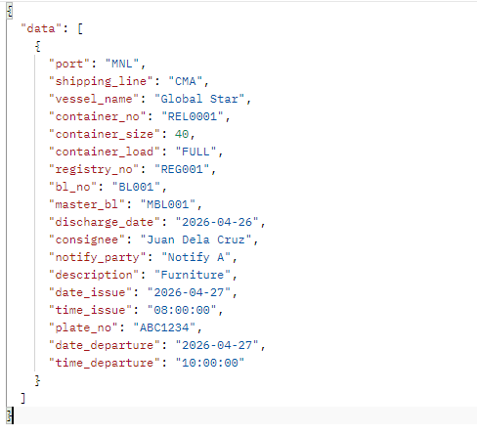

Load Sample Request
Endpoint: api/load.php
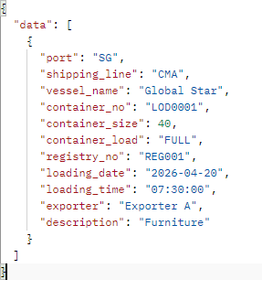

Discharge Sample Request
Endpoint: api/discharge.php
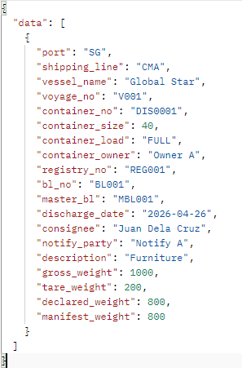

Receive Sample Request
Endpoint: api/receive.php
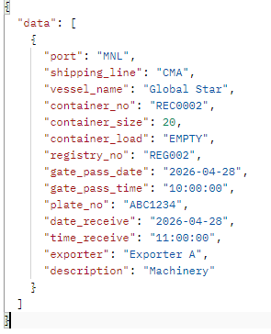

4. API Response

Status: Success
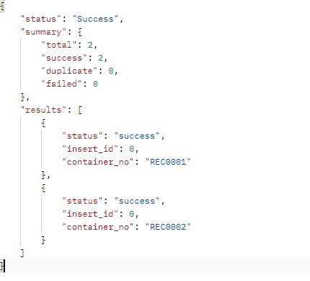
With Duplicate Entry Result
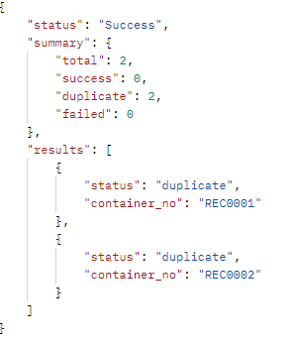

With failed Result Required fields
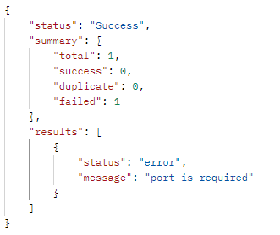

Status: Error
Invalid Request Format Request
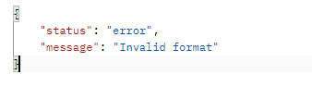
Invalid Token
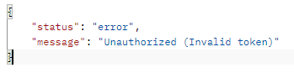
Missing Token
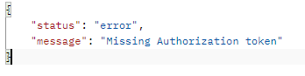
IP NOT WHITELISTED
